**Project Report**

1. **INTRODUCTION**
   1. **Project Overview**

This project is developed in **ServiceNow** to implement structured **User, Group, and Role Management** integrated with **Access Control Lists (ACL)** and **Automated Approval Workflows**.

In this system:

* Users such as **Project Manager (Alice)** and **Team Member (Bob)** are created.
* Groups such as **Managers** and **Developers** are configured.
* Roles are assigned to users and groups to maintain proper access control.
* A custom table called **User Access Management** is created to store access requests.
* Fields include:
  + Requested Role
  + Requested Group
  + Status (Pending / Approved / Rejected)
  + Approval Date
  + Comments
* ACLs are configured to secure the table using role-based permissions.
* A Flow is created in Flow Designer to automatically trigger approval requests and update status.

Overall, the system ensures **secure, automated, and efficient role-based access management**.

**1.2 Purpose**

The purpose of the project **“Optimizing User, Group, and Role Management with Access Control and Workflows”** is to implement secure access control and automated workflow approvals using ServiceNow.

This project aims to:

* Reduce manual role assignment errors
* Ensure users access only authorized resources
* Implement role-based access control (RBAC)
* Automate approval workflows
* Improve accountability and system security

By automating access approvals and enforcing ACL rules, the system minimizes unauthorized access and improves operational efficiency.

1. **IDEATION PHASE**
   1. **Problem Statement**

**Customer Problem Statement Template:**

|  |  |
| --- | --- |
| **Section** | **Content** |
| I am | A system user (Project Manager / Team Member / Admin). |
| I’m trying to | Access appropriate resources and manage roles securely. |
| But | Roles and permissions are unclear, and approvals are delayed. |
| Because | There is no structured RBAC system and automated workflow. |
| Which makes me feel | Confused, concerned about security, and inefficient. |

**Problem Statement Table:**

|  |  |  |  |  |
| --- | --- | --- | --- | --- |
| **I am** | **I’m trying to** | **But** | **Because** | **Which makes me feel** |
| A Project Manager | Monitor and approve access securely | Users access data without structured control | There is no automated approval workflow | Concerned about security risks |
| An Administrator | Manage users and roles efficiently | Role assignments are manual and inconsistent | RBAC and ACL are not properly enforced | Stressed about system integrity |

* 1. **Empathy Map Canvas**

An empathy map helps understand how users experience role management and workflow approvals.

It captures:

* Security concerns
* Workflow delays
* Access confusion
* Accountability expectations

This insight helps design a structured RBAC system with automated approval flow.

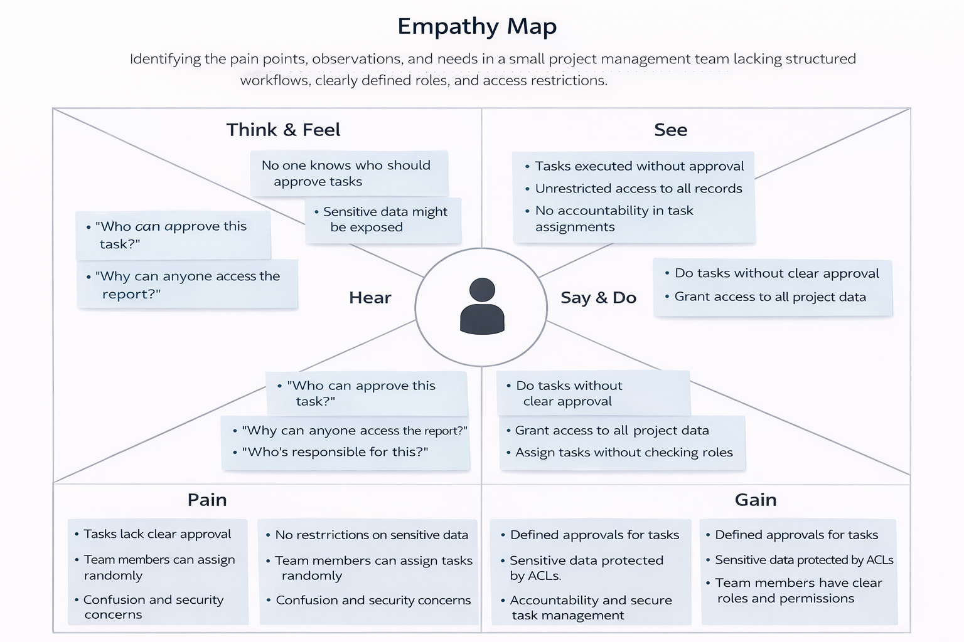.

* 1. **Brainstorming**

Step 1: Team Gathering, Collaboration & Problem Selection

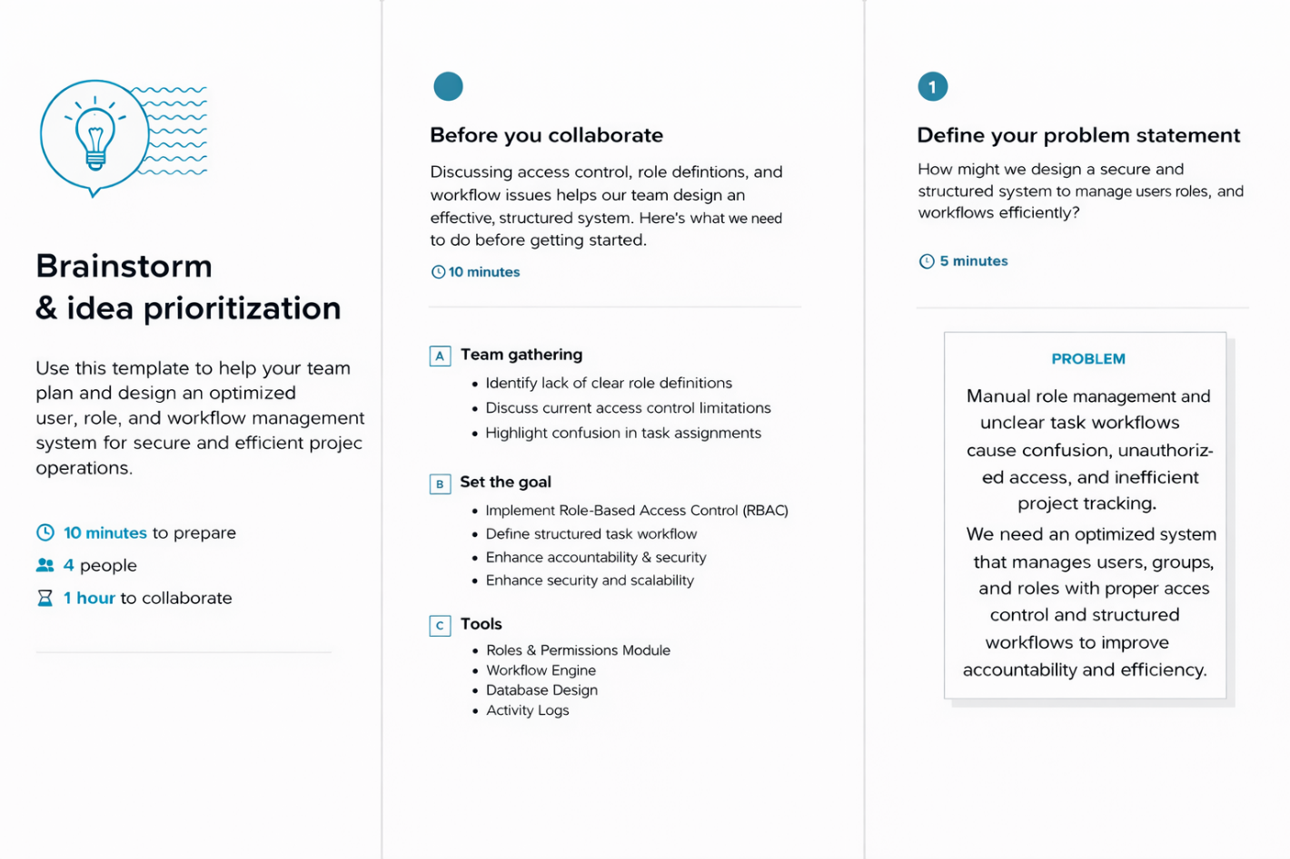

Step 2: Brainstorm, Idea Listing & Grouping

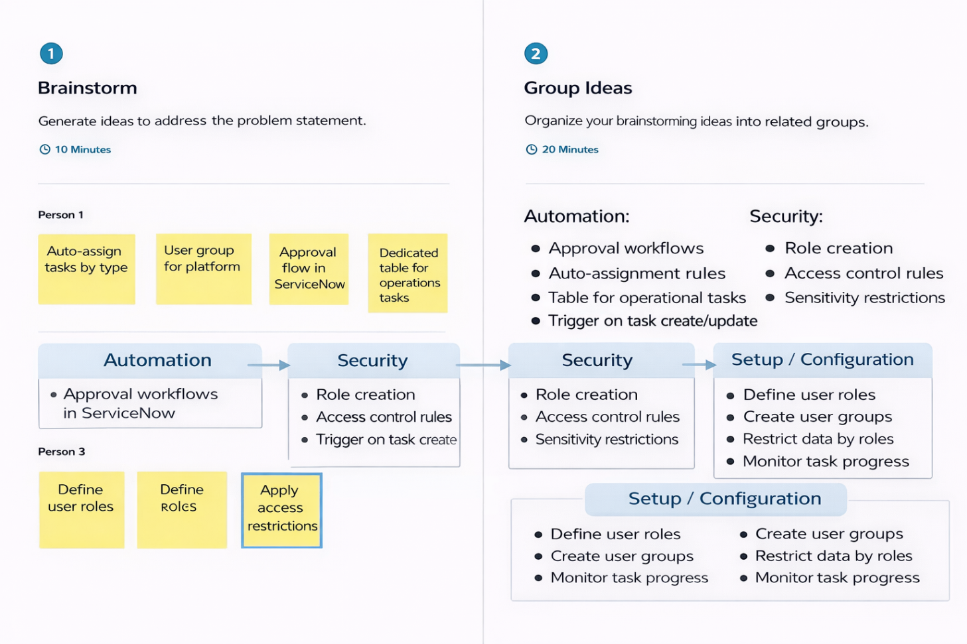

Step 3: Idea Prioritization

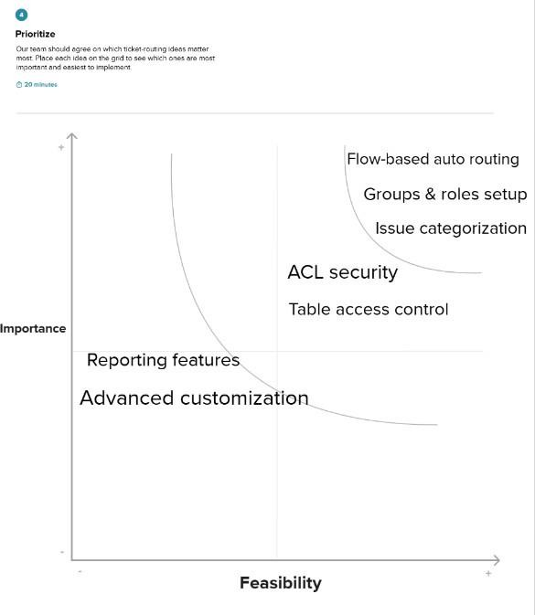

1. **REQUIREMENT ANALYSIS**
   1. 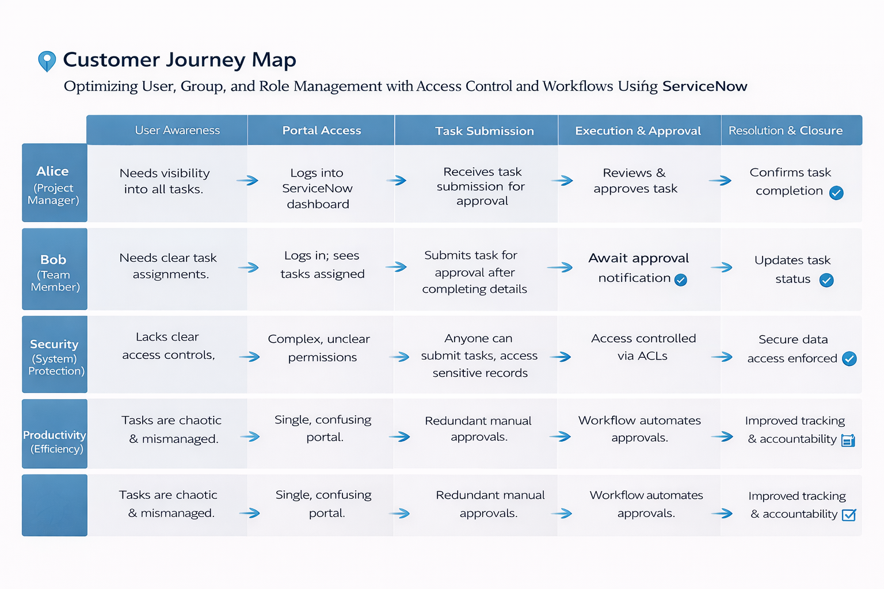**Customer Journey map**

* 1. **Solution Requirement**

**Functional Requirements:**

Following are the functional requirements of the proposed solution.

|  |  |  |
| --- | --- | --- |
| **FR No** | **Functional Requirement** | **Sub Requirement** |
| FR-1 | User Registration & Login | Secure login with role-based authentication |
| FR-2 | Role & Group Management | Create roles and assign to users |
| FR-3 | Access Control | Configure ACL for secure data visibility |
| FR-4 | Approval Workflow | Automated approval using Flow Designer |

**Non-functional Requirements:**

Following are the non-functional requirements of the proposed solution.

|  |  |  |
| --- | --- | --- |
| **NFR** | **Requirement** | **Description** |
| NFR-1 | Usability | User-friendly dashboard and forms |
| NFR-2 | Security | RBAC + ACL implementation |
| NFR-3 | Reliability | Accurate approval workflow execution |
| NFR-4 | Performance | Approval triggered within seconds |
| NFR-5 | Availability | 24/7 cloud-based system |
| NFR-6 | Scalability | Supports increasing users and requests |

* 1. **Data Flow Diagram**

* + 1. Data Flow Diagram (DFD) is a traditional visual representation of the information flows within a system. A neat and clear DFD can depict the right amount of the system requirement graphically. It shows h ow data enters and leaves the system, what changes the information, and where data is stored.
    2. **Example: (Simplified)**

Team manager

Project manager

Optimizing User, Group, and Role Management with Access Control and Workflows

**User Stories**

Use the below template to list all the user stories for the product. **User Type: Customer (Web User)**

|  |  |  |  |  |  |  |
| --- | --- | --- | --- | --- | --- | --- |
| **User Type** | **Functional Requirement (Epic)** | **User Story Number** | **User Story / Task** | **Acceptance Criteria** | **Priority** | **Release** |
| End User | Access Request | USN-1 | As a user, I can request access to a specific role or group through the system. | Access request is submitted successfully and workflow is triggered. | High | Sprint-1 |
| End User | Access Status Tracking | USN-2 | As a user, I can view the status of my access request. | I can see Pending, Approved, or Rejected status. | High | Sprint-1 |
| End User | Notifications | USN-3 | As a user, I receive notifications when my access request is approved or rejected. | Email/system notification is received upon status change. | Medium | Sprint-2 |
| End User | Access History | USN-4 | As a user, I can view my current roles and previous access requests. | All assigned roles and past requests are visible in dashboard. | Medium | Sprint-2 |

**User Type: Support Agent (Customer Care Executive)**

|  |  |  |  |  |  |  |
| --- | --- | --- | --- | --- | --- | --- |
| **User Type** | **Functional Requirement (Epic)** | **User Story Number** | **User Story / Task** | **Acceptance Criteria** | **Priority** | **Release** |
| Support Agent | Role-Based Access | USN-5 | As a support agent, I can view only the users, groups, and records assigned to my role. | Agent dashboard displays only authorized records based on assigned role. | High | Sprint-1 |
| Support Agent | Record Update | USN-6 | As a support agent, I can update user or group details based on my access permissions. | Changes are saved successfully and restricted to permitted fields. | High | Sprint-1 |
| Support Agent | Workflow Participation | USN-7 | As a support agent, I can approve or reject access requests assigned to me. | Approval or rejection updates the workflow status correctly. | Medium | Sprint-2 |
| Support Agent | Internal Notes / Comments | USN-8 | As a support agent, I can add internal comments during workflow processing. | Internal notes are saved and visible to authorized users only. | Medium | Sprint-2 |

**User Type: Administrator**

|  |  |  |  |  |  |  |
| --- | --- | --- | --- | --- | --- | --- |
| **User Type** | **Functional Requirement (Epic)** | **User Story Number** | **User Story / Task** | **Acceptance Criteria** | **Priority** | **Release** |
| Administrator | Role & Access Configuration | USN-9 | As an admin, I can configure role-based access control rules (ACLs). | Access permissions are enforced correctly based on assigned roles. | High | Sprint-1 |
| Administrator | Dashboard Monitoring | USN-10 | As an admin, I can monitor users, groups, and role assignments through a dashboard. | Dashboard displays total users, groups, active roles, and recent changes. | High | Sprint-1 |
| Administrator | Report Generation | USN-11 | As an admin, I can generate reports on user activity and role changes. | Reports display user access history, role assignments, and workflow approvals. | Medium | Sprint-2 |
| Administrator | User & Role Management | USN-12 | As an admin, I can create, update, or remove users, groups, and roles. | Users, groups, and roles can be added, edited, or deleted successfully. | High | Sprint-1 |

* 1. **Technology Stack**

| **Component** | **Technology** |
| --- | --- |
| User Interface | ServiceNow Service Portal |
| Application Logic | Business Rules, Flow Designer |
| Security | ACL, RBAC |
| Database | ServiceNow Cloud Database |
| Infrastructure | ServiceNow SaaS Cloud |

**Technical Architecture:**

The Deliverable shall include the architectural diagram as below and the information as per the table1 & table 2

**Example:** **Optimizing User, Group, and Role Management with Access Control and Workflows**

User

Access Request Form

Custom Table

Flow Trigger

Approval

Status Update

Approved

* 1. **Include all the processes (As an Application Logic / Technology Block)**

The system consists of the following key application logic components implemented in ServiceNow:

**• User Authentication & Role Management**

The system manages Users, Groups, and Roles effectively.

* Users are created and assigned to specific groups.
* Roles are mapped to users and groups.
* Access Control Lists (ACLs) are configured to restrict access based on roles.

This ensures secure login and proper permission control.

**• User & Group Management Module**

Administrators can:

* Create and manage users
* Create support groups
* Assign users to appropriate groups
* Control role inheritance

This module ensures structured organizational access.

**• Access Control & Security Module**

ACL rules are implemented to:

* Control read, write, create, and delete permissions
* Restrict unauthorized access to records
* Protect sensitive operational data

Security is enforced through role-based authorization.

**• Workflow & Process Automation Module**

Using **ServiceNow Flow Designer and Business Rules**:

* Processes are automated based on conditions
* Tasks are assigned to correct groups
* Status updates are managed automatically
* Manual intervention is minimized

This improves efficiency and reduces errors.

**• Notification Module (Email Alerts)**

SMTP Email Service is configured to send notifications when:

* Users are assigned new roles
* Records are created or updated
* Workflow status changes

This ensures real-time communication.

**• Reporting & Monitoring Module**

Admins can generate reports and dashboards to monitor:

* User activity
* Group performance
* Role assignments
* Workflow execution

This helps in auditing and performance tracking.

**2. Infrastructure Demarcation (Local / Cloud Architecture)**

The system follows a **cloud-based architecture using ServiceNow SaaS platform**.

**• Local Layer**

Users and administrators access the system through:

* Web Browser
* Internet connection

No local installation is required.

**• Cloud Layer**

Hosted on ServiceNow Cloud:

* Application Server
* Workflow Engine
* Access Control Engine
* Database Server
* File Storage

This ensures scalability, high availability, and secure data management.

**3. External Interfaces (Third-Party Integrations)**

The system integrates with:

**• SMTP Email Service**

For sending notifications related to workflows and role updates.

**• REST API Services (Optional)**

For integration with other enterprise systems if required.

**• Authentication Services (OAuth / LDAP – Optional)**

For secure enterprise-level login mechanisms.

**4. Data Storage Components**

The system uses a **relational database (ServiceNow internal database)** to store:

* User details
* Group details
* Role mappings
* Access control configurations
* Workflow records
* Audit logs

Attachments are stored using ServiceNow attachment storage.

**5. Machine Learning Interface (Future Enhancement)**

Future improvements may include:

* Intelligent role recommendation
* Automated access approval suggestions
* Anomaly detection in access patterns
* Predictive workflow optimization

These enhancements can be implemented using **ServiceNow Predictive Intelligence** to improve security and efficiency.

**Table-1: Components & Technologies:**

| **S.No** | **Component** | **Description** | **Technology** |
| --- | --- | --- | --- |
| **1** | **User Interface** | **Web-based platform where administrators manage users, groups, roles, and workflows** | **ServiceNow Platform UI (HTML, CSS, JavaScript)** |
| **2** | **Application Logic-1** | **User creation, role assignment, and validation logic** | **ServiceNow Business Rules** |
| **3** | **Application Logic-2** | **Access control enforcement and permission management** | **ServiceNow Access Control Lists (ACLs)** |
| **4** | **Application Logic-3** | **Workflow automation and approval processes** | **ServiceNow Flow Designer / Workflows** |
| **5** | **Database** | **Stores user records, group details, role mappings, workflow data, and audit logs** | **ServiceNow MySQL-based Internal Database** |
| **6** | **Cloud Database** | **Cloud-hosted database service ensuring availability and scalability** | **ServiceNow Cloud Platform** |
| **7** | **File Storage** | **Stores attachments related to user records or workflow documents (if applicable)** | **ServiceNow Attachment Storage** |
| **8** | **External API-1** | **Email notification service for role changes and workflow updates** | **SMTP Email Service** |
| **9** | **External API-2** | **Integration with enterprise authentication or external systems (optional)** | **REST API / LDAP / OAuth Integration** |
| **10** | **Machine Learning Model** | **Intelligent role recommendation and predictive workflow optimization (future enhancement)** | **ServiceNow Predictive Intelligence** |
| **11** | **Infrastructure (Server / Cloud)** | **Application hosted on secure cloud environment with high availability** | **ServiceNow SaaS Cloud Infrastructure** |

**Table-2: Application Characteristics:**

|  |  |  |  |
| --- | --- | --- | --- |
| **S.No** | **Characteristics** | **Description** | **Technology** |
| 1 | Open-Source Frameworks | Web technologies used in the user interface for managing users, groups, roles, and workflows | HTML, CSS, JavaScript (ServiceNow UI) |
| 2 | Security Implementations | Role-based access control, secure authentication, and encrypted data transmission | ServiceNow ACL, HTTPS, OAuth 2.0 / LDAP |
| 3 | Scalable Architecture | 3-tier cloud architecture that supports increasing numbers of users, groups, and workflow processes | ServiceNow Cloud Platform |
| 4 | Availability | 24/7 cloud availability with backup, monitoring, and high uptime reliability | ServiceNow SaaS Infrastructure |
| 5 | Performance | Fast execution of workflows, access validation, and role assignment processes | Indexed Database + Workflow Optimization |

1. **PROJECT DESIGN** 
   1. **Problem Solution Fit**

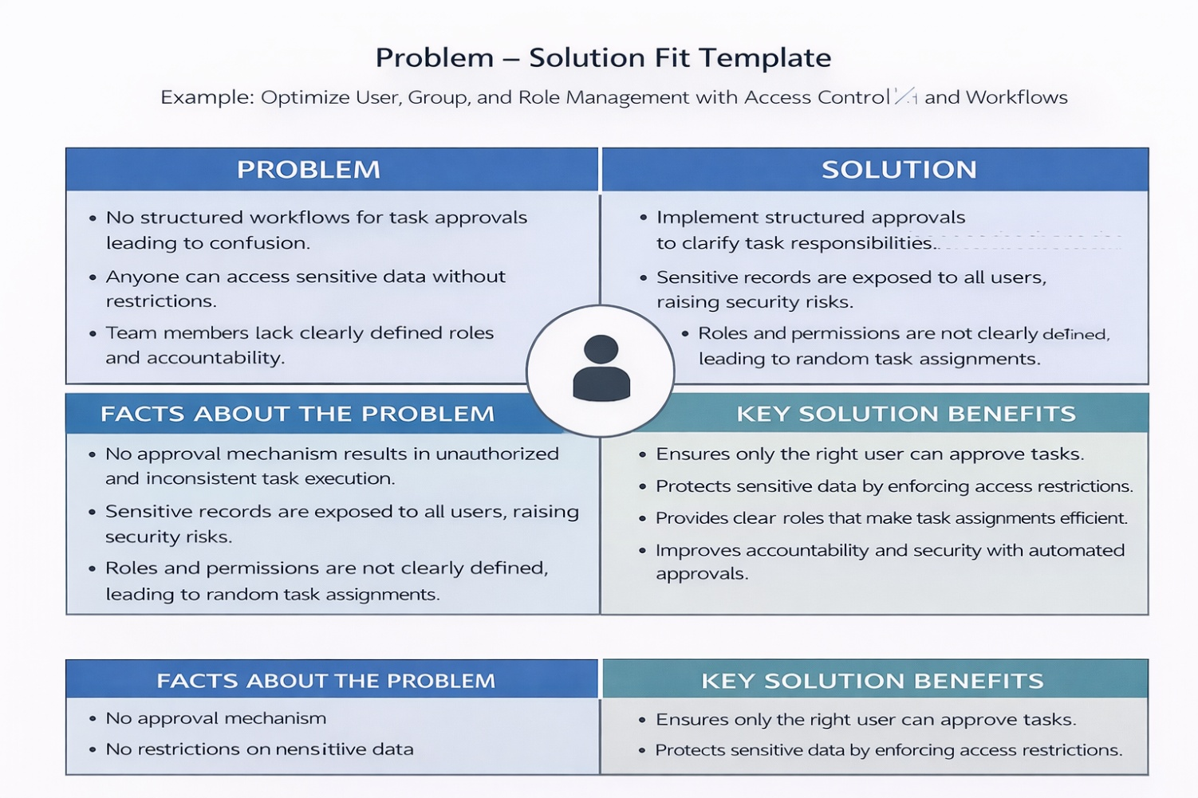

**Template:**

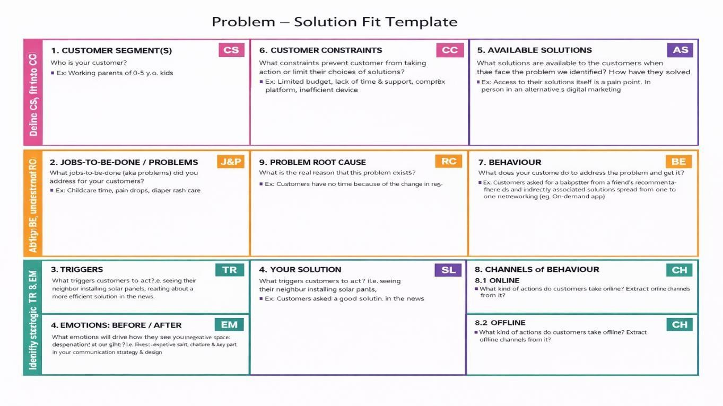

* 1. **Proposed Solution**

|  |  |  |
| --- | --- | --- |
| **S.No.** | **Parameter** | **Description (For Your Project)** |
| 1 | Problem Statement (Problem to be solved) | Manual management of users, groups, and roles in organizations can lead to improper access control, security risks, unauthorized data access, and inefficient workflow handling. Lack of automation increases administrative effort and errors. |
| 2 | Idea / Solution Description | Develop a centralized system in ServiceNow that automates user, group, and role management using Access Control Lists (ACLs) and Workflows. The system ensures secure authentication, structured role assignment, and automated approval processes. |
| 3 | Novelty / Uniqueness | Combines role-based access control with automated workflows to streamline user provisioning and permission management. Reduces manual configuration and improves security through structured automation. |
| 4 | Social Impact / Customer Satisfaction | Enhances data security and transparency within organizations. Reduces administrative workload and prevents unauthorized access, leading to better operational efficiency and user trust. |
| 5 | Business Model (Revenue Model) | Can be offered as a cloud-based SaaS solution for enterprises needing secure access management. Can be integrated into ITSM platforms or enterprise systems as a subscription-based service. |
| 6 | Scalability of the Solution | Highly scalable cloud-based solution capable of handling increasing numbers of users, groups, roles, and workflows. Can be extended with advanced automation, AI-based access recommendations, and enterprise integrations. |

* 1. **Solution Architecture**

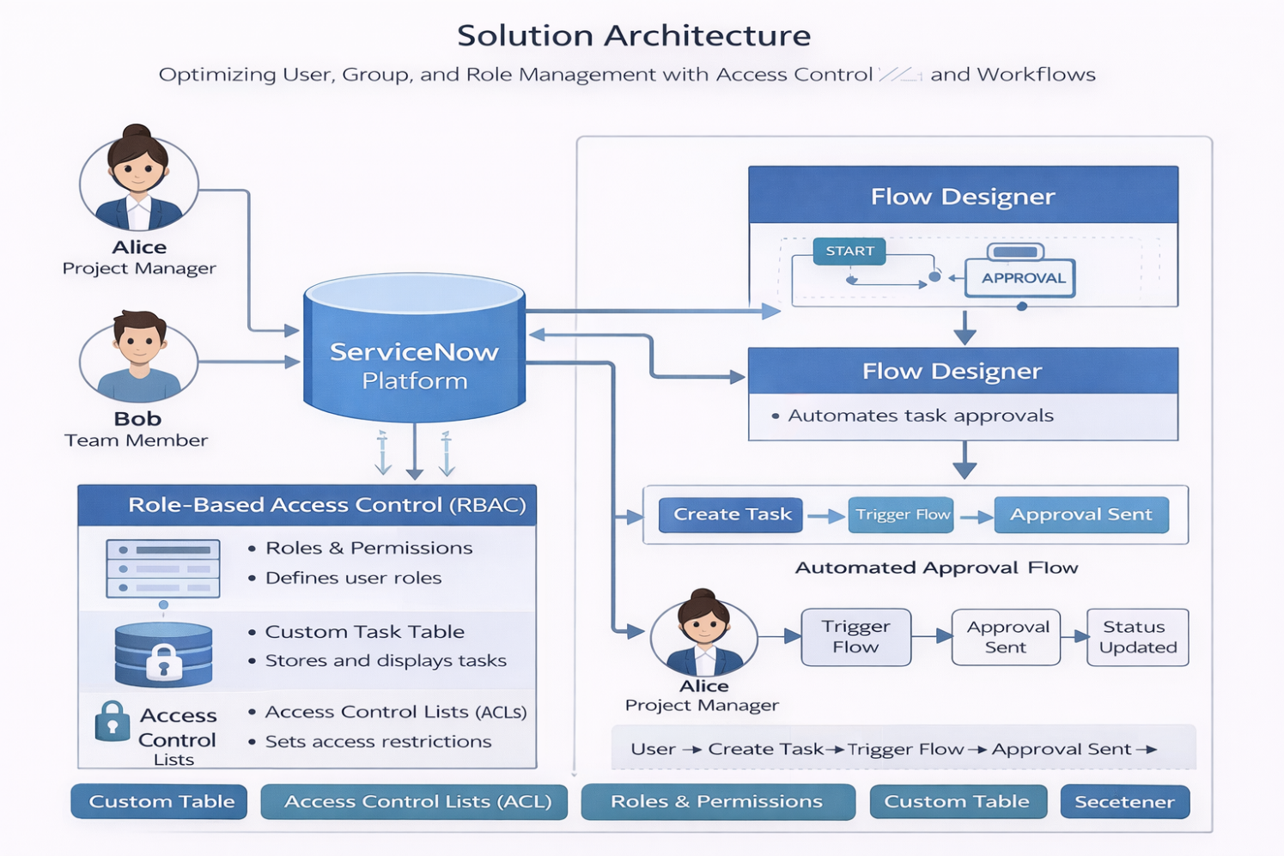

1. **PROJECT PLANNING & SCHEDULING** 
   1. **Project Planning**

Product Backlog, Sprint Schedule, and Estimation:

|  |  |  |  |  |  |  |
| --- | --- | --- | --- | --- | --- | --- |
| **Sprint** | **Functional Requirement (Epic)** | **User Story No** | **User Story / Task** | **Story Points** | **Priority** | **Team Members** |
| Sprint-1 | User Management | USN-1 | As an admin, I can create new users in the system with required details. | 2 | High | Dev-1, Dev-2 |
| Sprint-1 | User Authentication | USN-2 | As a user, I can securely log in using role-based authentication. | 1 | High | Dev-1 |
| Sprint-1 | Role Assignment | USN-3 | As an admin, I can assign roles to users based on responsibilities. | 3 | High | Dev-2 |
| Sprint-2 | Group Management | USN-4 | As an admin, I can create and manage user groups. | 2 | High | Dev-1 |
| Sprint-2 | Role-Based Access Control | USN-5 | As a system, I enforce access permissions using ACL rules. | 5 | High | Dev-2, Dev-3 |
| Sprint-2 | Workflow Automation | USN-6 | As a system, I automate approval workflows for user-role assignments. | 5 | High | Dev-3 |
| Sprint-3 | Notifications | USN-7 | As a user, I receive notifications when roles or permissions are updated. | 2 | Medium | Dev-1 |
| Sprint-3 | Dashboard | USN-8 | As an admin, I can view user, group, and role details in a dashboard. | 3 | High | Dev-2 |
| Sprint-3 | Reporting | USN-9 | As an admin, I can generate reports on user activity and role assignments. | 3 | Medium | Dev-3 |
| Sprint-4 | Security Enhancement | USN-10 | As a system, I secure user and access data using authentication and encryption. | 3 | High | Dev-1 |
| Sprint-4 | Audit & Monitoring | USN-11 | As an admin, I can track changes in roles and permissions through audit logs. | 1 | Low | Dev-2 |

Project Tracker, Velocity & Burndown Chart:

|  |  |  |  |  |  |  |
| --- | --- | --- | --- | --- | --- | --- |
| **Sprint** | **Total**  **Story**  **Points** | **Duration** | **Sprint**  **Start**  **Date** | **Sprint End**  **Date (Planned)** | **Story**  **Points**  **Completed** | **Sprint**  **Release Date**  **(Actual)** |
| Sprint- 1 | 20 | 3 Days | 10 Feb 2026 | 12 Feb 2026 | 20 | 12 Feb 2026 |
| Sprint- 2 | 20 | 3 Days | 13 Feb2026 | 15 Feb 2026 | 18 | 15 Feb 2026 |
| Sprint- 3 | 20 | 3 Days | 16 Feb2026 | 18 Feb 2026 | 20 | 18 Feb 2026 |
| Sprint- 4 | 20 | 2 Days | 19 Feb2026 | 20 Feb 2026 | 19 | 20 Feb 2026 |

Velocity:

AV = Sprint Duration / Velocity = 20/19 = 1 Burndown Chart:

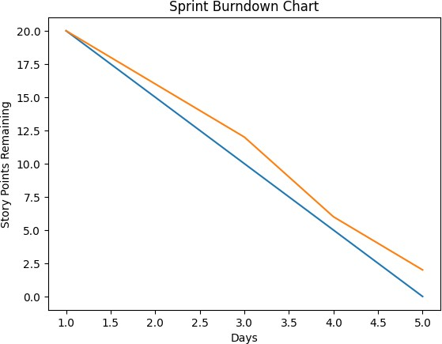

1. **FUNCTIONAL AND PERFORMANCE TESTING** 
   1. **Performance Testing 1. Model Performance Testing:**

* + 1. **Defect Analysis**

|  |  |  |  |  |  |
| --- | --- | --- | --- | --- | --- |
| **Resolution** | **Severity 1** | **Severity 2** | **Severity 3** | **Severity 4** | **Total** |
| Fixed | 4 | 5 | 3 | 2 | 14 |
| By Design | 1 | 2 | 1 | 1 | 5 |
| Duplicate | 0 | 1 | 1 | 0 | 2 |
| Not Reproduced | 0 | 1 | 0 | 0 | 1 |
| **Total** | **5** | **9** | **5** | **3** | **22** |

* + 1. **Test Case Analysis**

|  |  |  |  |  |
| --- | --- | --- | --- | --- |
| **Module** | **Total Cases** | **Pass** | **Fail** | **Not Tested** |
| Ticket Creation | 10 | 9 | 1 | 0 |
| Auto Assignment Flow | 12 | 11 | 1 | 0 |
| Issue Field & Choices | 6 | 6 | 0 | 0 |
| Business Rules | 5 | 5 | 0 | 0 |
| Dashboard View | 4 | 4 | 0 | 0 |
| Performance Testing | 5 | 4 | 1 | 0 |

1. **RESULTS** 
   1. **Output Screenshots**

Figure-1:

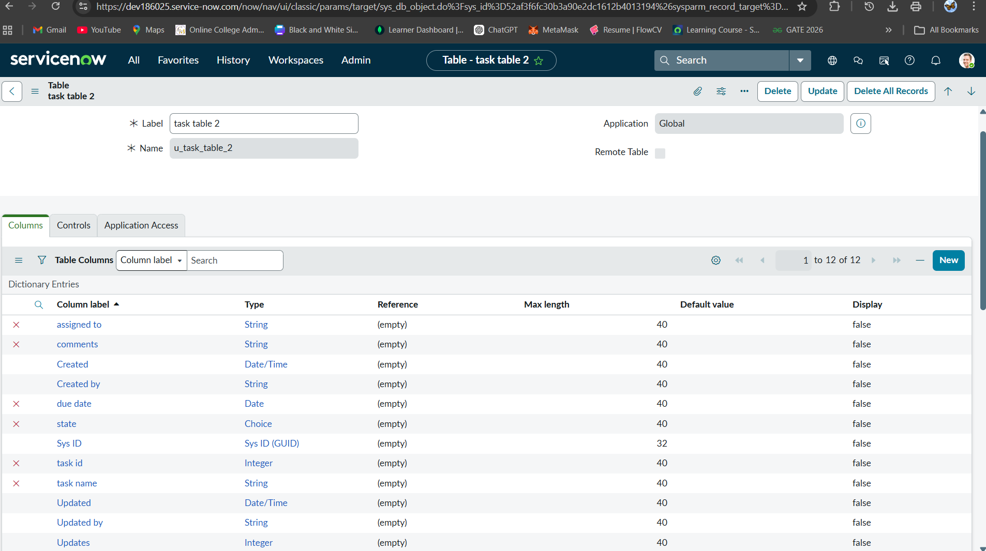

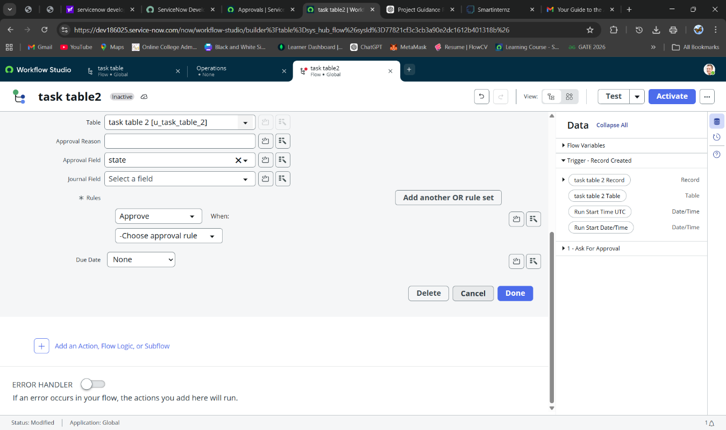Figure-2:

Figure- 3:

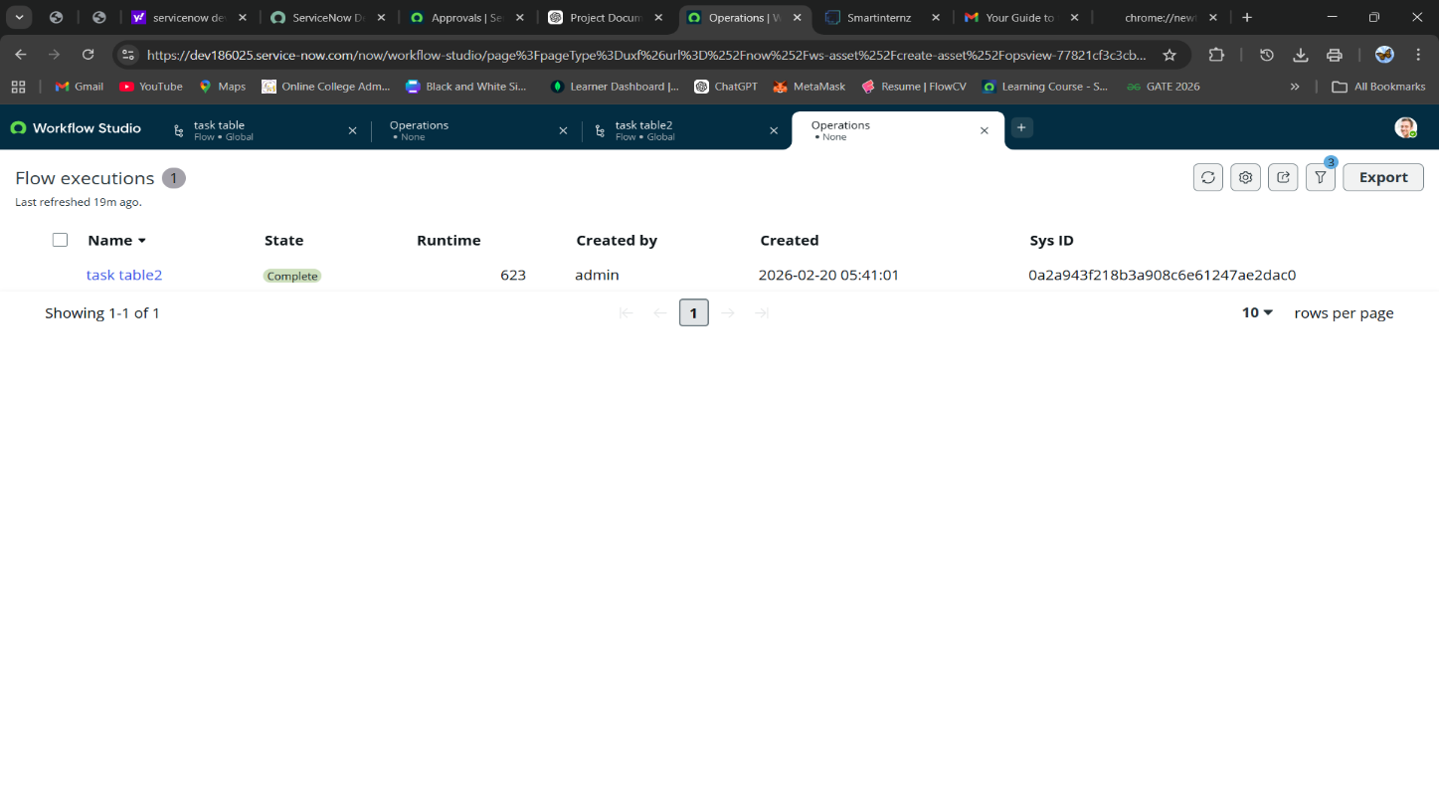

1. **ADVANTAGES & DISADVANTAGES**

**Advantages**

**1. Automated Approval Workflow**

**The system automates user-role assignments and access approval processes using workflows. This reduces manual intervention and speeds up permission management.**

**2. Role-Based Security**

**Access Control Lists (ACLs) ensure that only authorized users can view, edit, or manage specific records. This enhances data security and prevents unauthorized access.**

**3. Reduced Manual Errors**

**Automation minimizes mistakes that commonly occur in manual user and role assignment processes, improving system reliability.**

**4. Improved Accountability**

**All actions such as role assignment, access updates, and workflow approvals are tracked. Audit logs help maintain transparency and accountability within the organization.**

**5. Scalable Architecture**

**The cloud-based ServiceNow platform supports growing numbers of users, groups, and workflows without performance issues. The system can be easily expanded for enterprise-level use.**

**Disadvantages**

**1. Requires Proper ACL Configuration**

**If Access Control Lists are not configured correctly, users may gain unauthorized access or face permission issues. Careful configuration is required.**

**2. Manual Updates Needed for New Roles**

**When new roles or organizational structures are introduced, administrators must manually update role mappings and workflows.**

**3. No AI-Based Decision Logic Yet**

**The current system uses rule-based automation only. It does not include intelligent role recommendation or predictive access management features.**

1. **CONCLUSION**

The project **“Optimizing User, Group, and Role Management with Access Control and Workflows”** successfully demonstrates how structured automation and role-based security can improve organizational access management in ServiceNow.

By implementing user creation, group management, role assignment, Access Control Lists (ACLs), and automated workflows, the system ensures secure authentication and controlled access to data. The workflow automation reduces manual effort, minimizes errors, and improves operational efficiency.

The project enhances security, transparency, and accountability within the organization. Overall, it provides a scalable and reliable solution for managing users, roles, and permissions effectively in a cloud-based environment.

1. **FUTURE SCOPE**

**1. AI-Based Role Recommendation**

Implement intelligent suggestions for role assignment based on user responsibilities and historical access patterns.

**2. Automated Access Review**

Periodic automated review of user permissions to detect unnecessary or risky access rights.

**3. Integration with Enterprise Systems**

Integration with HR systems or Active Directory to automatically provision users based on employee onboarding processes.

**4. Advanced Security Monitoring**

Implement anomaly detection to identify suspicious access behavior.

**5. Self-Service Access Requests**

Develop a self-service portal where users can request access, which triggers automated approval workflows.

**6. Multi-Level Approval Workflows**

Introduce hierarchical approval processes for sensitive role assignments.

Implement intelligent automation to categorize tickets automatically based on description.

**11. APPENDIX GitHub Link:**

https://drive.google.com/file/d/1G-_s0lBLQGQlJEoASRaAHqR4PB3nuzIk/view?usp=sharing